PAWS Fall 2014/Winter 2015 Newsletter
Animal Fest 2014 a Big Success

Thanks to everyone who worked so hard to make Animal Fest 2014 a huge success.
Our great t-shirts are still on sale for $20 each.
T-shirt sales are part of how we raise money to care for the animals in our no-kill shelter!
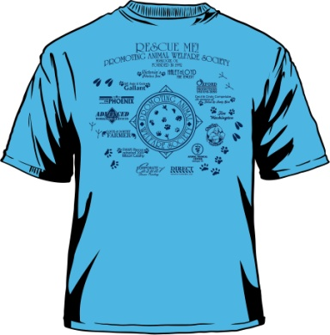A special thanks to our sponsors: 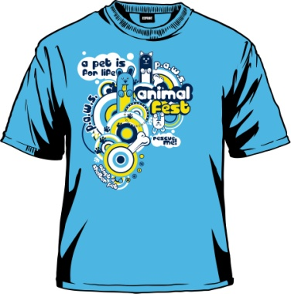
Cecil & Cindy Compelube
Victoria's Photo's Inc.
Dorothy & Louis Farmer
Tommie Sue Leahy
Tim Washington
Animal Medical Center
Charlie's Chicken East
Jeff & Angie Gallant
Corporate To Casual
Direct Traffic Control, Inc.
Oxford Productions
Muskogee Phoenix
Haley & Loyd Jewelry
Advanced Workzone Services
Firstar Bank

Also, we greatly appreciate the donations from our friends at:
Tractor Supply-pet contest prizes and free give always
Victoria's Photo, Inc. - Donated Photo Shoot
Charlie's Chicken - Monetary and gift coupons
Cagle Flowers
Muskogee Phoenix, newspaper ads
Corporate To Casual - Monetary
Salon Secret - Shampoo and Conditioner gift bag
Bebb Flowers - Gift Certificate
Malones BBQ
Bella Mea's
Whishhouse, free night stay and continental breakfast
Patsy Rodin
Shelle Hamlin - Joan Rivers Bracelette
Edward, Hektor and Daisy Gallant - 2 iPods and iTunes gift cards
Applebee's - 2 Gift Cards
Red Lobster - 2 Gift Cards
Kate Schroeder - Hand made silver necklace
Terry & Mary Eddings
Girl Scouts – cases of cookies

Also, a big shout out to our Animal Fest volunteers: Jessie and Carol Ann Everett, Linda Lee, Sue Cote, Louis & Dorothy Farmer, Elouise Farmer, Lacy Guinn, Paul Betow, Cindy Compelube, Kem & Paige Frix.

PAWS Has Many Great Dogs & Cats for Adoption!

If you know of someone that would make a great pet owner and has a fenced-in yard (for dogs), have them give us a call at (918) 686-7297.

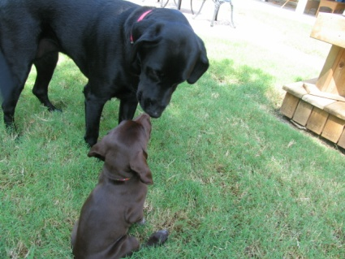Before bringing a new dog into your home, please carefully consider the needs and characteristics of the breed. Some breeds require a great deal of outside exercise, or even a "job" to do in order to be healthy and happy. Other breeds are real lap dogs or good around children or other animals. Do your homework before you adopt!

Donations are what keep us going! 
Sheila Hamilton & Sheih, Jason Hamilton - Donation in memory of Falise Guffey
Clark & Nancy Lipotich - Donation in memory of Barbara Green
Theida Osteen - Donation in memory of Falise Gruffey
Patsy Rodin - Donation and brought cookies for employees
Christine Cannarsa - Archer - Donation for spay/neuters
Cynthia Harrell - Donation
Marie O'Brien - Donation
Mark & Melanie Juntti - Donation
Juliene Adams - Donation
Johnina Wardwell - Donation
Walls Bargain Center - Donated 8 bags of dog food.
Southern Ag. in Tulsa - Donated a whole pallet of dog and cat food
Okla. City Food Bank thru Okla. Alliance - Donated 1600 lbs. of canned dog food in August
Victoria Carvajal - Donation
Joan Beasley - Donation
Virginia Williams - Donation
Jim & Elaine Murray - Donation for taking dog from Brushy Mountain Fire House dog was about to have babies.
Marshall & Brenda Helsley - Donation
Chris & Elaine Hensley - Donation in memory of Chloe Buffington
Brenda Wescott - Donatiion
Norman McFaddden - Best Choice UPC Bar Codes

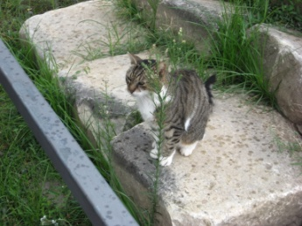SPAY & NEUTER: Nationwide, more than three million cats and dogs are euthanized in shelters annually. Often they are the offspring of cherished family pets, even purebreds. Be sure to spay or neuter your pet!

Membership Renewals
Kate Schroeder - Renewed Individual
Joan Beasley - renewed Grand PAW
Virginia Williams - Renewed Individual
Bruce Green - Renewed Family
Judith Anderson - Renewed Individual
Austin & Bates Kenyon - Renewed Family
Leisha Haworth - Renewed Bronze
Janet Niezgoda - Renewed Individual
Leo & Shirrell Durbin - Renewed Family
Sue Cote - Renewed Bronze
Wren Stratton - Renewed Individual
Jim & Tracy Blair - Renewed Family

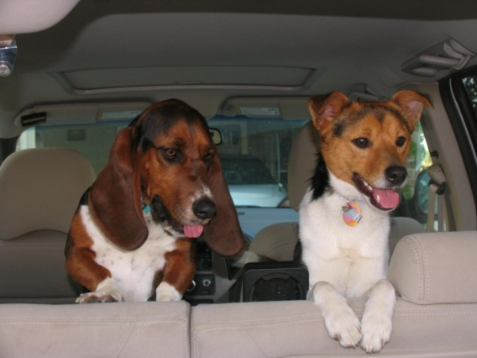
Going on Vacation and can’t take the pets?
PAWS can board your furry friends! Please call us at 918-686-7297 to make a reservation.

Director’s Notes by Dorothy Farmer
JUST ONE LITTER….What does pet overpopulation have to do with shelters? Just about everything. It's hard to imagine that letting your pet have one or even two litters cause a problem, especially if you find homes for most of the puppies or kittens. But the fact is that "just one litter" does cause pet overpopulation. In less than a year, pet's litter could be having litters of their own. Every day, thousand of healthy puppies and kittens must be destroyed and each one of those thousands came from "just one litter." This is why everyone that takes in a cat or dog be responsible pet owner and get them spay/neutered.

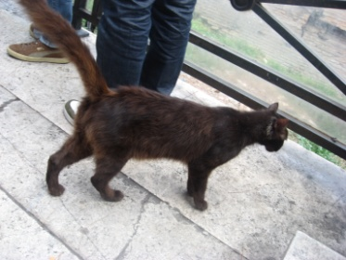
2014 PAWS Adoption Summary

47 Pet adoptions
4 Transports to other states for adoption*
61 low-income spay/neuter
15 low-income spay/neuter who did not keep their vet appointments

*PAWS has only recently begun transporting animals to states with a high demand for pets. We look
Forward to growing this program so our dogs and cats can have loving homes.

PLEASE DON'T BE BACKYARD BREEDER

Is it all right to breed my pet if I find good homes for all the offspring?

Each time you place one of your pet's puppies or kittens in a loving home, there is one fewer potential home for another shelter animal. There are already more than enough animals for every potential home and each day tens of thousands of dogs and cats are destroyed because no one wants them. If you have a friend who wants a puppy or kitten or dog or cat, urge that friend to adopt one from a local shelter. This will save one more dog or cat from a tragic fate. Please stop breeding help the over population of animals already here. We just don't need more breeding lots of these little dog end up on the street and end up in a shelter.

TIPS

All new pets don't come into your home and feel like they have been their forever, it may take 2 to 3 months for them to really feel at home and comfortable. Don't rush them and have patients. Good nutrition and socialization are about the best thing you can do for them. Give them time to get adjusted and learn your rules and schedule. Try to put yourself in their place and think how would I feel after being dumped and shoved from place to place it would be hard for anyone to know they finally belong somewhere from now on. Make them know it by plenty of interaction, exercise and lots of one-on-one with plenty of love and affection. I can promise you it will come back to you many times.

HOW I CAN HELP PAWS

Here are some quick and easy ways you can help PAWS:

-Hold a garage sale, bake sale or car wash and donate proceeds to PAWS in your name.
-Collect aluminum cans(ex. pop, beer, energy drinks) and bring them to PAWS. We get money for recycling them.
-Collect Best Choice UPC Bar Codes and send or bring by to PAWS. Better yet, collect them from co-workers, friends and neighbors too!
-A child can host a child's birthday party where they ask friends to bring a "present" for the animals at PAWS instead of for themselves.
-Donation of food, kitty litter or office supplies, stamps or gift cards from Lowe's, Wal Mart, paper towels, Dish washer powder, HE Washing machine liquid soap, Dawn liquid soap, Mr. Clean for mopping.
-In memory of the loss of a beloved pet or an animal lover in your family, why not honor them by making a donation in your beloved pet's name to PAWS.

A Special “THANKS TO VOLUNTEERs”

Thanks to the following volunteers - Linda Lee a past board member she does PAWS Face Book Page. Chad Farmer for doing the PAWS Web page for years.

Carol Anne Cleland and Jessie Everett for helping PAWS with many things, walking dogs, helping with transports, running errands. Rose Mary Lemley for being faithful with coming and spending time with dogs and cats to help socialize the animals. She does great job! Louis Farmer for many years of mowing the yard, weed eating and brush hog mowing our pasture, repairing many things saving PAWS money and picking up food and supplies and many things to help too numerous to mention.

Patsy Rodin for making shelter folks goodies to eat. All the board members! Angie Gallant for putting together the Newsletter after Dorothy gets her all the info for the year. And many thanks to all the people that adopted some of our great pets we have for adoption and giving them a good home.

Many thanks to Paul Betow for doing a great job and first time at Animal Fest Pet Contest it was lots of fun for everyone. And all the volunteers that helped make Animal Fest a fun and successful event. Also all the people that donated some great gifts for our raffle and the sponsors that their names went on the back of our Animal Fest T-shirts.

A Big Thanks to Animal Medical Center and Dr.'s Gloyd Miller and Tim Synar and their staff for all the help they have given PAWS from when we first came into being!

Many students that get Cherokee money have to do volunteer hours for ever how much money they get that semester. Some people that have committed a crime depending on what the crime is may get to do community service at PAWS through the court.

2015 PAWS Yearly Members Meeting
February 25, 2015 at 12:00 p.m.
at the Muskogee Non-Profit Resource Center, 207 N. 2nd Street, Muskogee, OK

2015 PAWS Board of Director’s Meeting Dates:
May 13
July 22
September 23
All board meetings begin at 12:00 p.m. at the
Muskogee Non-Profit Resource Center, 207 N. 2nd Street, Muskogee, OK

Pet Treats:
Cheesy Chicken Delights - Makes 20 to 30 bite-size treats
These soft cookies are full of cheese and chunks of chicken. Most dogs love these tasty treats.

1 - 7.75-ounce package of Bisquick Complete Three Cheese Biscuits
1/2 Cup precooked chicken, chopped into 1/4-inch pieces
1/4 Cup grated cheddar cheese
1/2 c
Cup water

1. Preheat the oven to 350 degrees.
2. Mix together all the ingredients into sticky dough.
3. Drop by teaspoon onto greased cookie sheets.
4. Bake for 10 to 15 minutes or until golden brown.
5. Remove from the oven, let cool thoroughly, and store in an airtight container in the
refrigerator.

Liver (or Tuna) Puffs – makes 13 dozen

1 1/2 Cups whole wheat flour
1 Cup all purpose flour
1 package unflavored gelatin
1 package dry yeast (about 2 1/2 teaspoons)
1/4 Cup very warm water
1 Cup powdered dry milk
1/4 Cup corn oil
1 egg
1 - 6 ounce can liver (or tuna)
1/4 Cup water

Dissolve yeast in warm water. Mix dry ingredients in large bowl. Add yeast, oil, egg,
canned liver or tuna and water. Mix well (dough will be very stiff). Drop 1/2 teaspoon
onto ungreased cookie sheet. Bake 25 minutes at 300 degrees. Store in refrigerator. Hope your dog or even some cats love this.

A POEM:
I wish someone would tell me what it is I've done so wrong!
Why do I have to stay chained up and be left alone so long.
They seemed so happy to have me. When I came here as a pup
There were so many things we'd do while I was growing up.
The master said he'd train me as a companion and a friend
The mistress said she'd never fear to be alone again.
The children said they'd feed me if only I would stay.
But now the master hasn't time.
The mistress says I shed.
She doesn't want me in the house.
Not even to be fed.
The children never walk me.
They always say not now.
I wish that I could please them.
Won't someone tell me how?
All I have you see, is my love.
I wish they would explain
why they say they want me,
and now they leave me on a chain.

Love you forever,

Your four-legged friend

